**Hybrid hierarchical method for**

**electrocardiogram heartbeat classification**

1. **Preprocessing: Filtering & Segmentation**

* bandpass filter with a range 0.5–40 Hz
* Segmented heartbeat using dynamic segmentation strategy

1. **Feature Extraction**

-dynamic features are utilised in this paper

to describe each heartbeat using DWT and RR features.

- PCA is

suggested in the proposed method to find a sub-space

1. **Classification & Classifier**

-classified using SVM. An overall accuracy of 96.67%

* SVM is a binary classifier proposed by Vapnik

1. **Accuracy**

-the first stage are 98.40% and 97.50% respectively.

-For the second stage, 94.94% and 93.19%

1. **Two Leads or One Lead ? In case of two leads .. how classification of two leads is merged to have final decision ?**

-Two Leads

A fusion step has been considered to achieve the final decision by

using the rejection and Bayesian approaches. An 86.4% overall

accuracy

-Stacked generalization method

**Classes**

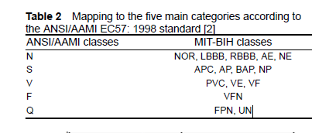

**NOTES :**

**-** The features reduction step is needed due to the high dimension of

the extracted features which may cause redundancies and irrelevant

information

- *Rejection method:* If the decision of the heartbeat from lead 1

and lead 2 is the same, the rejection method takes this beat into

consideration. However, if the decision is different, the

rejection method neglects this beat for a further manual

classification process as shown in Fig. 6 which is considered as

the main drawback for this method as the system will not be

fully automated.

ii. *Stacked generalisation method:* Stacked generalisation [32] is

used mainly to combine different models to enhance the

predictive results. Its main idea is that the training data is

divided into two disjoint sets